Assignment 3
16-bit ALU

Introduction: -
ALU is the fundamental building block of the processor, which is responsible for carrying out the arithmetic, logic functions, Shift functions and Comparison functions.

Specification:
- ALU Operands (A, B)
- ALU Result (ALU_OUT)
- ALU operands and output Result are of 16-bit width.
- ALU Result (ALU_OUT) is registered.
- The ALU function is carried out according to the value of the ALU_FUN input signal stated in the table in the following page and any other value for ALU_FUN not stated in the table, ALU_OUT must equal to 16’b0
- Arith_flag is activated "High" only when ALU performs one of the arithmetic operations (Addition, Subtraction, Multiplication, division), otherwise "LOW"
- Logic_flag is activated "High" only when ALU performs one of the Boolean operations (AND, OR, NAND, NOR, XOR, XNOR), otherwise "LOW"
- CMP_flag is activated "High" only when ALU performs one of the Comparison operations (Equal, Greater than, less than), otherwise "LOW"
- Shift_flag is activated "High" only when ALU performs one of the shifting operations (shift right, shift left), otherwise "LOW"

ALU_FUN Table
ALU_OUT | Operation | ALU_FUN
 | Arithmatic : Addition | 0000
 | Arithmatic : Subtraction | 0001
 | Arithmatic : Multiplication | 0010
 | Arithmatic : Division | 0011
 | Logic : AND | 0100
 | Logic : OR | 0101
 | Logic : NAND | 0110
 | Logic : NOR | 0111
 | Logic : XOR | 1000
 | Logic : XNOR | 1001
Equal to 1 | CMP: A = B | 1010
Equal to 2 | CMP: A > B | 1011
Equal to 3 | CMP: A < B | 1100
 | SHIFT: A >> 1 | 1101
 | SHIFT: A << 1 | 1110

Hint: Use Case statement to describe the behavior of this table and use default case if needed.
Hint: You can use if statement inside case branches

Block Interface

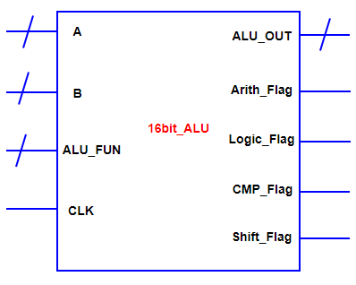

- Write a Verilog Code to capture the above specifications as well as the synthesis diagram of your code.
- Write a testbench to test all the ALU functions with operating clock frequency 100 KHz

